

# 

### Semester Two Examination, 2018

### Question/Answer booklet

# MATHEMATICS

**SOLUTIONS**

**APPLICATIONS**

**UNITS 1 AND 2**

## Section One:

## Calculator-free

|  |  |  |  |  |  |  |  |  |  |  |
| --- | --- | --- | --- | --- | --- | --- | --- | --- | --- | --- |
| Student number: In figures |  |  |  |  |  |  |  |  |  |  |

In words

Your name

## Time allowed for this section

Reading time before commencing work: five minutes

Working time: fifty minutes

## Materials required/recommended for this section

***To be provided by the supervisor***

This Question/Answer booklet

Formula sheet

***To be provided by the candidate***

Standard items: pens (blue/black preferred), pencils (including coloured), sharpener,  
correction fluid/tape, eraser, ruler, highlighters

Special items: nil

## Important note to candidates

No other items may be taken into the examination room. It is **your** responsibility to ensure that you do not have any unauthorised material. If you have any unauthorised material with you, hand it to the supervisor **before** reading any further.

## Structure of this paper

|  |  |  |  |  |  |
| --- | --- | --- | --- | --- | --- |
| Section | Number of questions available | Number of questions to be answered | Working  time (minutes) | Marks available | Percentage of examination |
| Section One:  Calculator-free | 8 | 8 | 50 | 52 | 35 |
| Section Two:  Calculator-assumed | 13 | 13 | 100 | 98 | 65 |
|  | | |  | **Total** | 100 |

## Instructions to candidates

1. The rules for the conduct of examinations are detailed in the school handbook. Sitting this examination implies that you agree to abide by these rules.

2. Write your answers in this Question/Answer booklet.

3. You must be careful to confine your response to the specific question asked and to follow any instructions that are specified to a particular question.

4. Supplementary pages for the use of planning/continuing your answer to a question  
have been provided at the end of this Question/Answer booklet. If you use these pages to continue an answer, indicate at the original answer where the answer is continued, i.e. give the page number.

5. Show all your working clearly. Your working should be in sufficient detail to allow your answers to be checked readily and for marks to be awarded for reasoning. Incorrect answers given without supporting reasoning cannot be allocated any marks. For any question or part question worth more than two marks, valid working or justification is required to receive full marks. If you repeat any question, ensure that you cancel the answer you do not wish to have marked.

6. It is recommended that you do not use pencil, except in diagrams.

7. The Formula sheet is not to be handed in with your Question/Answer booklet.

Section One: Calculator-free 35% (52 Marks)

This section has**eight (****8)** questions. Answer **all** questions. Write your answers in the spaces provided.

Working time: 50 minutes.

Question 1 (5 marks)

(a) Solve the equation for . (2 marks)

|  |
| --- |
| **Solution** |
|  |
| **Specific behaviours** |
| ✓ expands LHS  ✓ collects like terms and solves |

(b) Ash, Billie and Chris collected a total of cans to recycle. Ash collected twice as many cans as Chris, Chris collected more cans than Billie and Billie collected cans.

Determine how many cans Billie collected. (3 marks)

|  |
| --- |
| **Solution** |
|  |
| **Specific behaviours** |
| ✓ indicates number of cans each has  ✓ forms and simplifies equation  ✓ correct number |

Question 2 (5 marks)

The number of daily absentees at a small school over consecutive days are listed below:

(a) Determine the five-number summary for this data. (3 marks)

|  |
| --- |
| **Solution** |
| Ordered: {3, 4, 4} , 4 , {5, 5, 6} , 6 , {6, 6, 6} , 7, {7, 7, 9}  Median is 6  Q1 is 4, Q3 is 7  Summary is 3, 4, 6, 7 and 9 |
| **Specific behaviours** |
| ✓ Min and Max  ✓ Median  ✓ Q1 and Q3 |

(b) Use the five-number summary to construct a box-plot on the scale below. (2 marks)

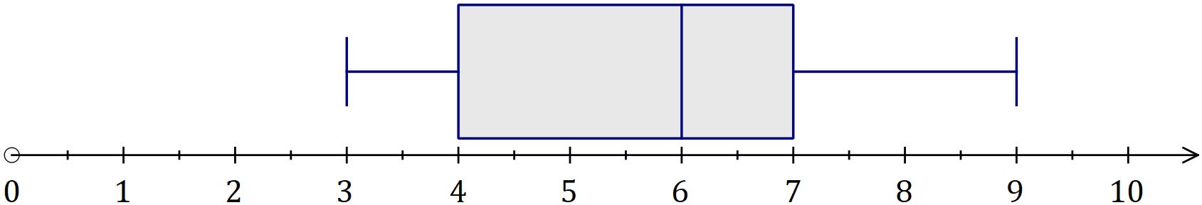

|  |
| --- |
| **Solution** |
| See graph |
| **Specific behaviours** |
| ✓ correctly locates five-number summary points (ft from a)  ✓ draws box and whiskers |

Question 3 (7 marks)

(a) The graph of is shown below. Determine the values of and . (2 marks)

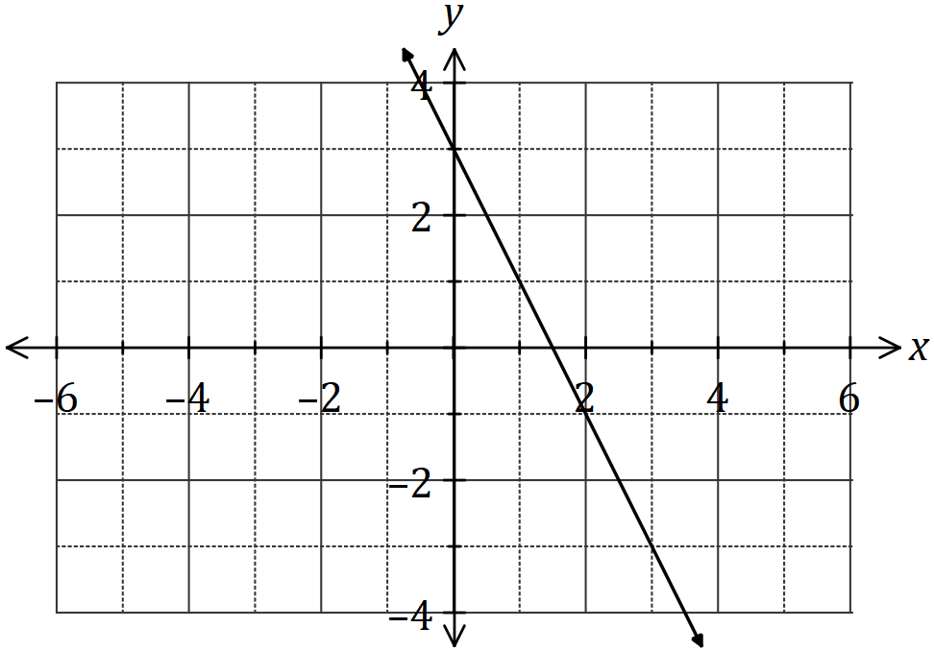

|  |
| --- |
| **Solution** |
|  |
| **Specific behaviours** |
| ✓ correct value for  ✓ correct value for |

(b) Draw the graph of the line on the axes below. (3 marks)

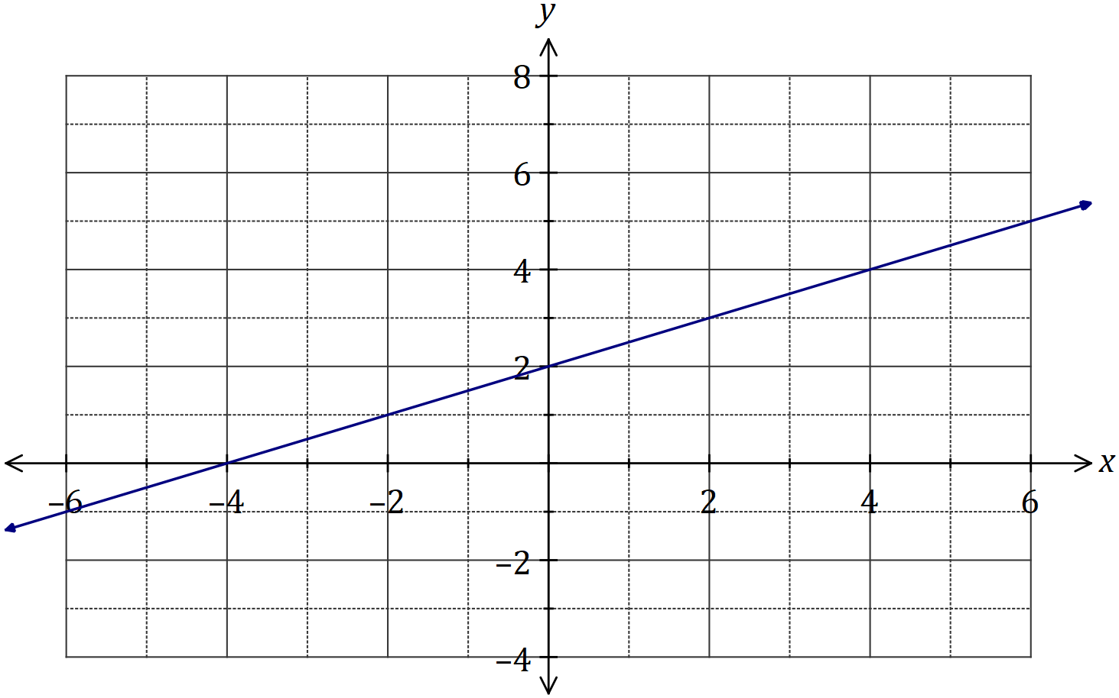

|  |
| --- |
| **Solution** |
| See graph |
| **Specific behaviours** |
| ✓ -intercept  ✓ -intercept  ✓ line drawn is straight |

(c) Determine the gradient of the line . (2 marks)

|  |
| --- |
| **Solution** |
|  |
| **Specific behaviours** |
| ✓ rearranges into form  ✓ states gradient |

Question 4 (8 marks)

(a) The power consumed by a device can be calculated using the formula .

Calculate the value of when

(i) and . (2 marks)

|  |
| --- |
| **Solution** |
|  |
| **Specific behaviours** |
| ✓ substitutes correctly, simplifying and  ✓ evaluates correctly |

(ii) and . (2 marks)

|  |
| --- |
| **Solution** |
|  |
| **Specific behaviours** |
| ✓ substitutes correctly, simplifying and  ✓ evaluates correctly |

(b) The variable is related to diameters and by the formula .

Calculate the value of when

(i) , and . (2 marks)

|  |
| --- |
| **Solution** |
|  |
| **Specific behaviours** |
| ✓ substitutes correctly, simplifying  ✓ evaluates correctly (anything equivalent) |

(ii) , and . (2 marks)

|  |
| --- |
| **Solution** |
|  |
| **Specific behaviours** |
| ✓ substitutes correctly, simplifying  ✓ evaluates correctly |

Question 5 (6 marks)

The graph below shows the cost , in dollars, of taking a journey of km with a taxi company.

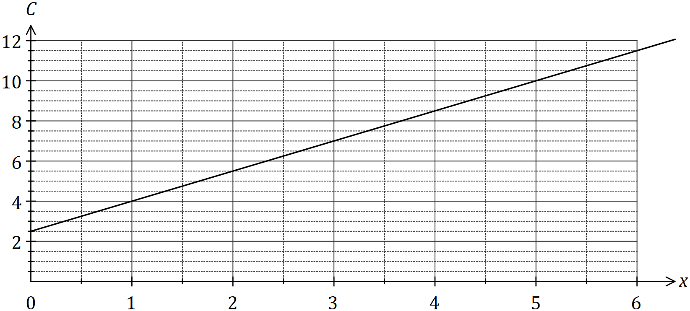

(a) State the cost of taking a journey. (1 mark)

|  |
| --- |
| **Solution** |
|  |
| **Specific behaviours** |
| ✓ correct cost |

(b) How much more expensive is a journey compared to one of ? (1 mark)

|  |
| --- |
| **Solution** |
|  |
| **Specific behaviours** |
| ✓ correct difference |

(c) State and interpret, in context, the value of the vertical axis intercept of the graph.

(2 marks)

|  |
| --- |
| **Solution** |
| , a fixed cost payable regardless of distance travelled. |
| **Specific behaviours** |
| ✓ value, ✓ interprets as fixed cost, flag-fall, etc |

(d) State and interpret, in context, the value of the gradient of the graph. (2 marks)

|  |
| --- |
| **Solution** |
| , the cost per kilometre of a journey is |
| **Specific behaviours** |
| ✓ value, ✓ interprets as cost per kilometre |

Question 6 (6 marks)

The heights of -year old boys are normally distributed with a mean of and a standard deviation of .

(a) Use the rule to determine the approximate percentage of -year old boys that can be expected to have heights between

(i) and . (2 marks)

|  |
| --- |
| **Solution** |
|  |
| **Specific behaviours** |
| ✓ indicates sd from mean  ✓ correct percent (full marks if CAO) |

(ii) and . (2 marks)

|  |
| --- |
| **Solution** |
|  |
| **Specific behaviours** |
| ✓ indicates sd above mean  ✓ correct percent (full marks if CAO) |

(b) Nurses at a health clinic measure the heights of children and refer anyone with a height that is more than two standard deviations from the mean of the child's age group to a doctor.

The last eight boys, aged , who attended the clinic had the following heights:

Determine, with justification, how many of these boys were referred. (2 marks)

|  |
| --- |
| **Solution** |
| Not referred if height between 101 and 117 cm.  So, **one** boy referred (118 cm). |
| **Specific behaviours** |
| ✓ correct number  ✓ justification (eg standard score or states **both** bounds) |

Question 7 (7 marks)

(a) The lines with equations and are shown on the axes below.

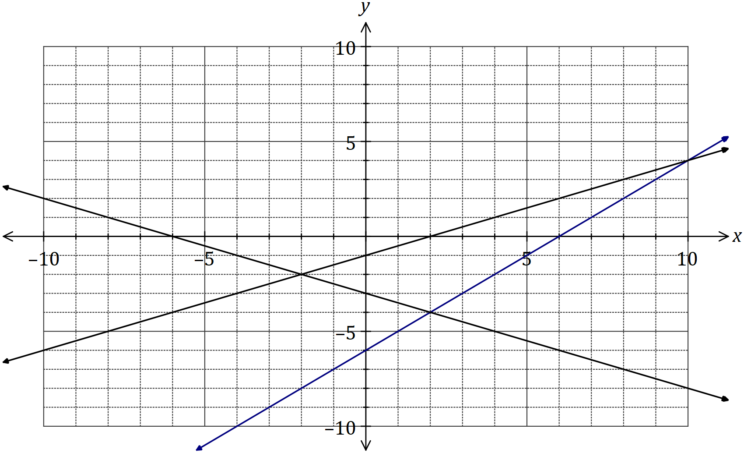

|  |
| --- |
| **Solution** |
| See graph |
| **Specific behaviours** |
| ✓ -intercept  ✓ -intercept |

(i) Draw the line on the axes above. (2 marks)

(ii) **Show on the graph** how to solve the simultaneous equations and

and **state** the solutions.. (2 marks)

|  |
| --- |
| **Solution** |
| From graph, |
| **Specific behaviours** |
| ✓ indicates with dashed lines on graph  ✓ correct values of and |

(b) Solve the simultaneous equations and . (3 marks)

|  |
| --- |
| **Solution** |
|  |
| **Specific behaviours** |
| ✓ indicates use of substitution or elimination  ✓ solves for  ✓ solves for |

Question 8 (8 marks)

A group of friends who frequently travelled abroad exchanged foreign currency between themselves using the conversion table below. For example, members of the group could exchange dollars for dinars or kroner for Australian dollars.

|  |  |  |  |  |
| --- | --- | --- | --- | --- |
| Country/Currency | Australian/Dollar | | | |
|  |  |  |  |
| Denmark/Kroner |  |  |  |  |
| Japan/Yen |  |  |  |  |
| Kuwait/Dinar |  |  |  |  |
| Thailand/Baht |  |  |  |  |

(a) How many baht can be exchanged for Australian dollars? (1 mark)

|  |
| --- |
| **Solution** |
|  |
| **Specific behaviours** |
| ✓ correct amount |

(b) How many Australian dollars can be exchanged for yen? (2 marks)

|  |
| --- |
| **Solution** |
| Dinars |
| **Specific behaviours** |
| ✓ appropriate method  ✓ correct amount |

(c) Before travelling to Kuwait, one of the group exchanged Australian dollars for the local currency. How many dinars did they receive? (2 marks)

|  |
| --- |
| **Solution** |
|  |
| **Specific behaviours** |
| ✓ appropriate method  ✓ correct amount |

(d) Another member of the group exchanged Australian dollars for a mixture of kroner and some yen. Determine the amount of Japanese currency they received.

(3 marks)

|  |
| --- |
| **Solution** |
|  |
| **Specific behaviours** |
| ✓ converts kroner to dollars  ✓ calculates remaining dollars  ✓ converts dollars to yen |

Supplementary page

Question number: _________

© 2018 WA Exam Papers. Kennedy Baptist College has a non-exclusive licence to copy and communicate this document for non-commercial, educational use within the school. No other copying, communication or use is permitted without the express written permission of WA Exam Papers. SN245-123-2.